Guide - Register New Temporary CW in SuccessFactors

Objective

Step by Step
- Access SuccessFactors at https://performancemanager4.successfactors.com/login?company=Contoso&amp;loginMethod=SSO
- Navigate to "Add Contingent Worker"
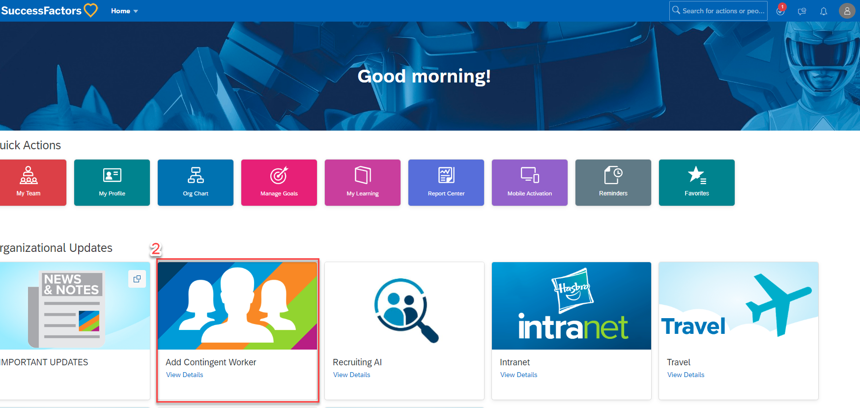
- Fill in the requested information
- At this step, define the responsible Manager (who will approve and renew the account when the period ends).
- In the "Company Email required" field, select "Yes" if the new account needs an email address. Select "No" if it is just a generic account that will not use email.
- Select the vendor of the temporary worker.
- Finally, define the account start and end dates. The period cannot exceed 1 year.
- Click "Continue" and enter the necessary comments. The request will be submitted and will go through the approval process (approvers will be defined based on the manager indicated in step 4).

Version History
Author | Version | Date | Description
Lucas Souza | 1.0 | Jun/2026 | Translation to PT-BR

